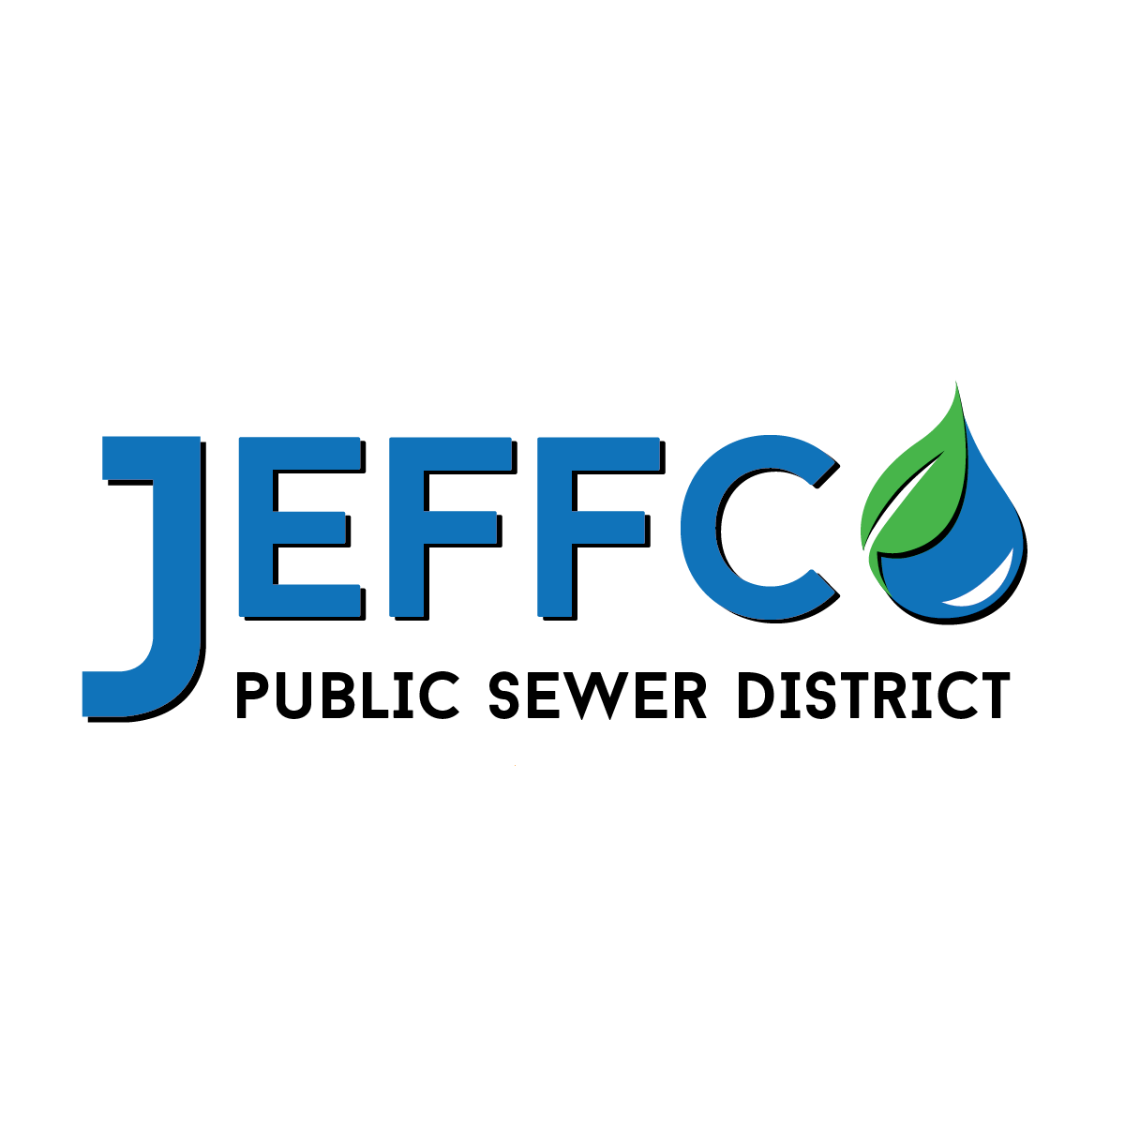
P: 636.797.9900 | F: 636.797.8436 CUSTOMER CONTACT INFORMATION

JCPSD Welcomes you! How would you like to be contacted? Please fill out the
information below and mail this form back to JCPSD, PO Box 632, Hillsboro, MO, 63050.

Date___________________________ ACCT #___________________

Service Address______________________________________________________________________________

Billing Address ______________________________________________________________________________
Where do you want your bills mailed?

Service Begin Date _____________________________

Customer First Name ___________________________ Last Name _____________________________

Email: ________________________________

Phone ________________________________ Alternate Phone ______________________________

If registering a joint utility account. Please fill out this section.

Co-Customer First Name _________________________ Last Name _____________________________

Email ________________________________

Phone _______________________________ Alternate Phone ______________________________

You are the Renter □ You are the Owner □

Bills are due on the ___ of the month. Delinquent bills are subject to disconnection ten days after the due date. Property Owners are required to pay a $100.00 security deposit for a ¾ or 1 inch meter. Renters / Lessees also pay a $100.00 deposit. Call 636.797.9900 for additional information.

In the event of default, you agree to pay for all reasonable services incurred to collect the charges for services rendered by JCPSD, which may include the following: all reasonable attorney’s fees, court costs and collection services.
Please click box if you wish to opt out of sharing your personal information with 3rd parties. □

________________________ ________________________ ___________________
Applicant Signature Co-Applicant Signature Date

